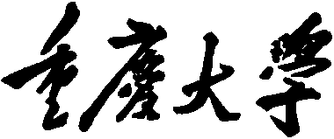
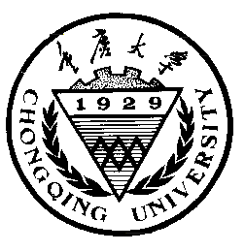

Personal Learning Portfolio

Course： English Academic Writing Teacher： Zhang Mei
Class： 001 Major： CS
Name： Student Number：
Class Time： 2024.02-2024.06
Grade：

Self | Teaching Assistant | Teacher
9

Comments：

Teacher (Signature)
Contents

Research Methodology
- My learning
- In class
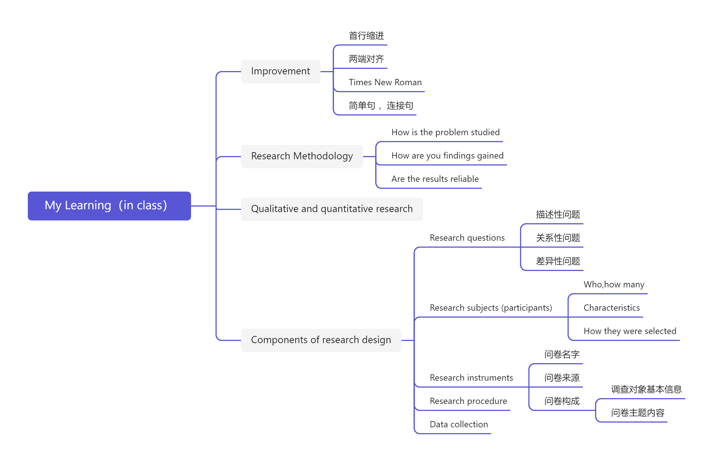
- Out of Class
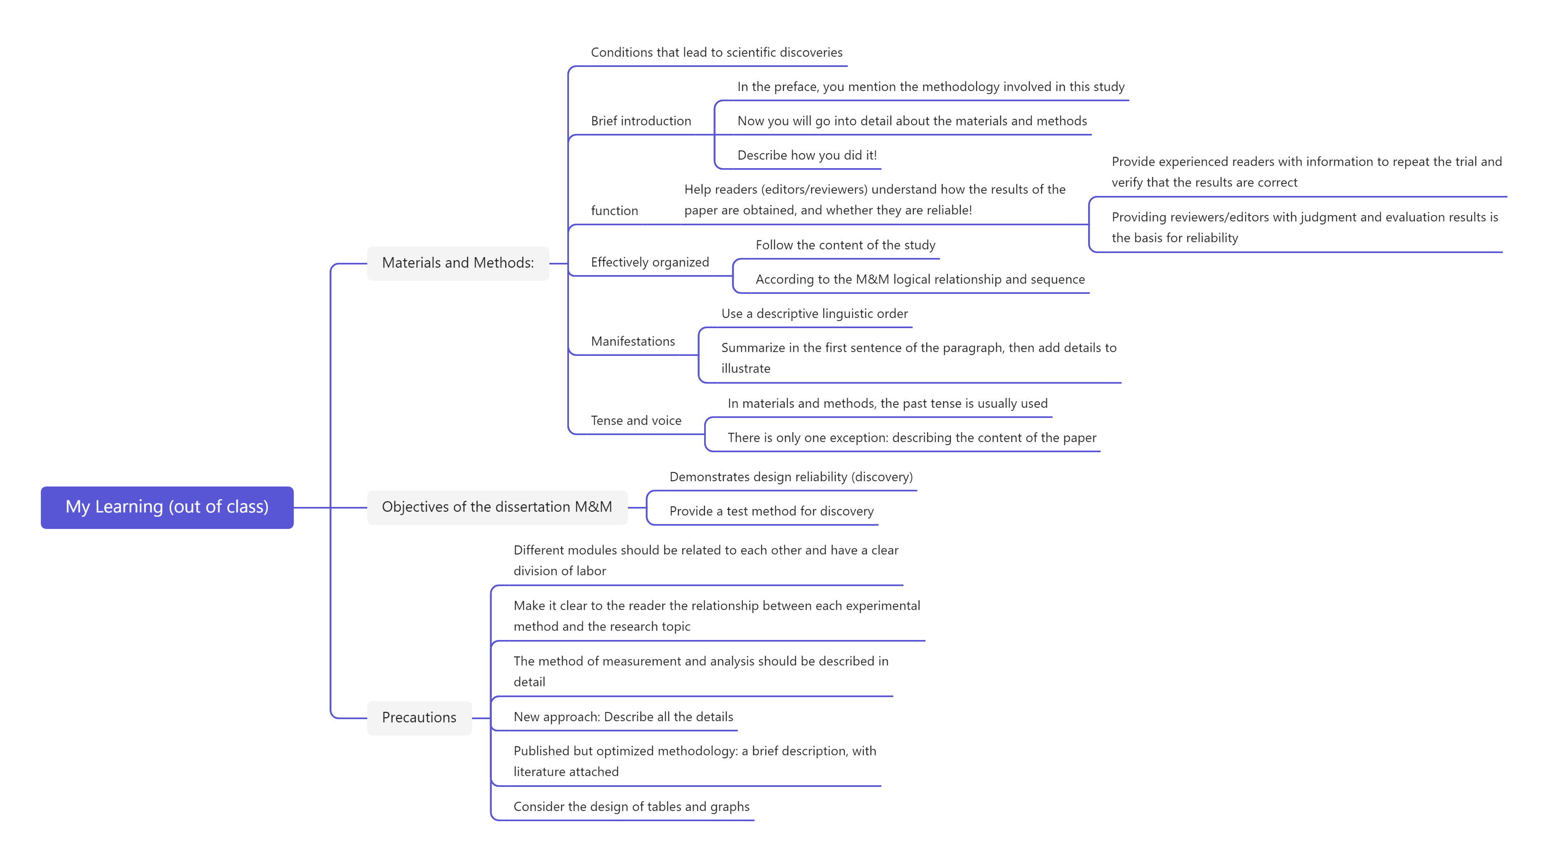
- Learning outcomes
1）In class
1) When I was writing my paper, I knew to use the Times New Roman font, with the first line indented and the ends aligned.
2) The next time I describe a research question, I know that it should be divided into descriptive questions, relational questions, and difference questions.
3) When I'm writing a questionnaire, I should figure out where the question is coming from.
2）Out of Class
1) When I was designing the goal of M&M, I needed a reliable surface design and a test method to be found.
2) When I write materials and methods, I should be careful to use the past tense.
3) When I write the materials and methods, I need to pay attention to this part at all times to help the reader understand how the results of the paper are obtained.
- My behavior and attitude
1）Out of Class
1.1 Autonomous learning (Online + Offline)
1.1.1 Online (CET-6 online course)
1.1.2 Offline (memorize vocabulary and listen to CET-6 listening exercises)
1.2 Homework
I completed my English assignment promptly with a diligent and meticulous attitude, ensuring it was not procrastinated until the deadline.
1.3 Cooperative learning
2）In Class
2.1 Individual performance (Take notes promptly and attentively focus during class).
2.2 Cooperation (Actively participate in classroom discussions)
4．Improvement
1）Out of Class
Through studying MOOCs, I learned what is the purpose of writing the materials and methods part of a paper, and how to write this part to help readers understand how the results of the paper are obtained.
2）In Class
In this class, I learned about the main components of the reasearch methodology, and understood the precautions and improvements in thesis writing.

